**Course Methods Test 3 Year 12**

Student name: ________________ Teacher name: ________________

**Task type: Response/Investigation**

**Reading time for this test : 5 mins**

**Working time allowed for this task: 40 mins**

**Number of questions: ____6_______**

**Materials required:** No classpads

Standard items: Pens (blue/black preferred), pencils (including coloured), sharpener, correction fluid/tape, eraser, ruler, highlighters

Special items: Drawing instruments, templates, notes on one unfolded sheet of   
A4 paper

**Marks available: __38____ marks**

**Task weighting: _14___%**

**Formula sheet provided: No but some formulae given on page 2**

**Note: All part questions worth more than 2 marks require working to obtain full marks.**

**Useful formulae**

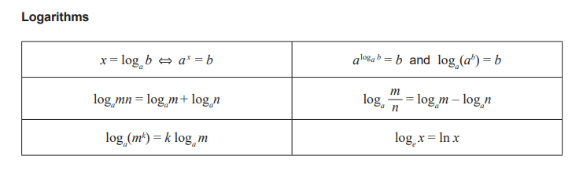

Q1 (2 & 2 = 4 marks)

Express each of the following as a **single logarithm**.

1. .
2. .

Q2 (2 & 2 = 4 marks)

Solve each of the following, giving your answer in **exact** form.

a)

b) 

Q3 (1, 3 & 3 = 7 marks)

The Richter scale,, of an earthquake of intensity  is given by  where  is a minimum intensity level used for comparison.

1. Determine  for an earthquake with intensity .
2. An earthquake measuring 5 on the Richter scale is how many times as intense as that of one measuring 4 on the Richter scale?
3. If an earthquake registers  on the Richter scale and a second earthquake registers  on the Richter scale, how many more times as intense is the second earthquake?

Q4 (3 marks)

Consider the function  which undergoes a transformation  where  are constants. The graph  is plotted below, determine the values of showing reasoning.

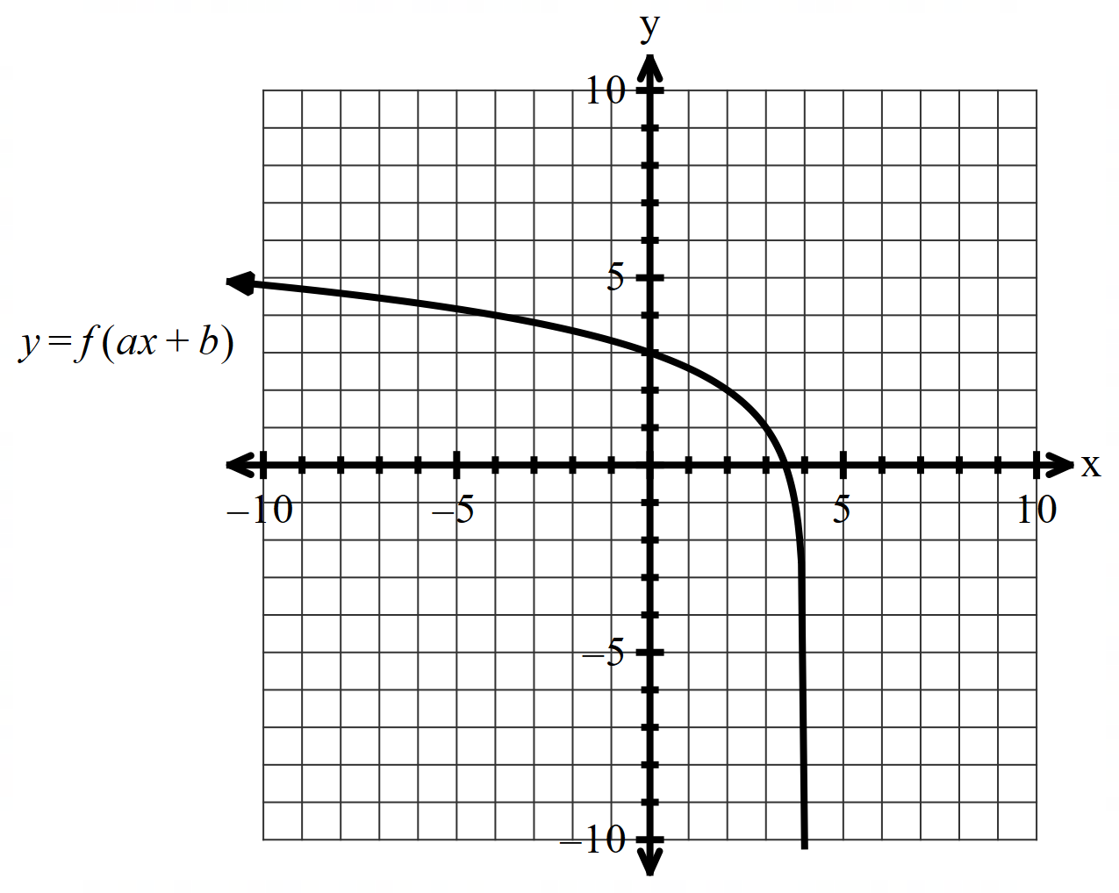

Q5 (3 & 5 = 8 marks)

Consider the function .

1. Determine .(Simplify)
2. Use the result from part a to determine .

Q6 (3, 3, 3 & 3 = 12 marks)

Consider the continuous random variable  and its probability density function which is graphed below.

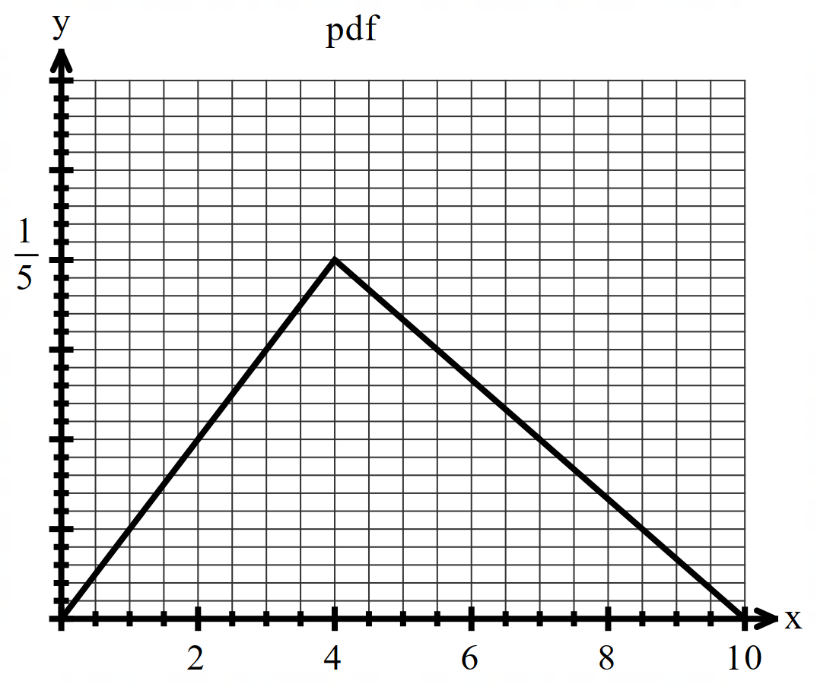

1. Determine the following **exactly**.
2. .(Simplify)
3. .(No need to simplify)

Q6 continued on next page

Q6 continued

1. E(X) i.e the mean. (No need to simplify)
2. Derive the cumulative probability function  for .

**End of test**

**Working out space**